Certifications & Professional Development

AWS CERTIFIED CLOUD PRACTITIONER Course
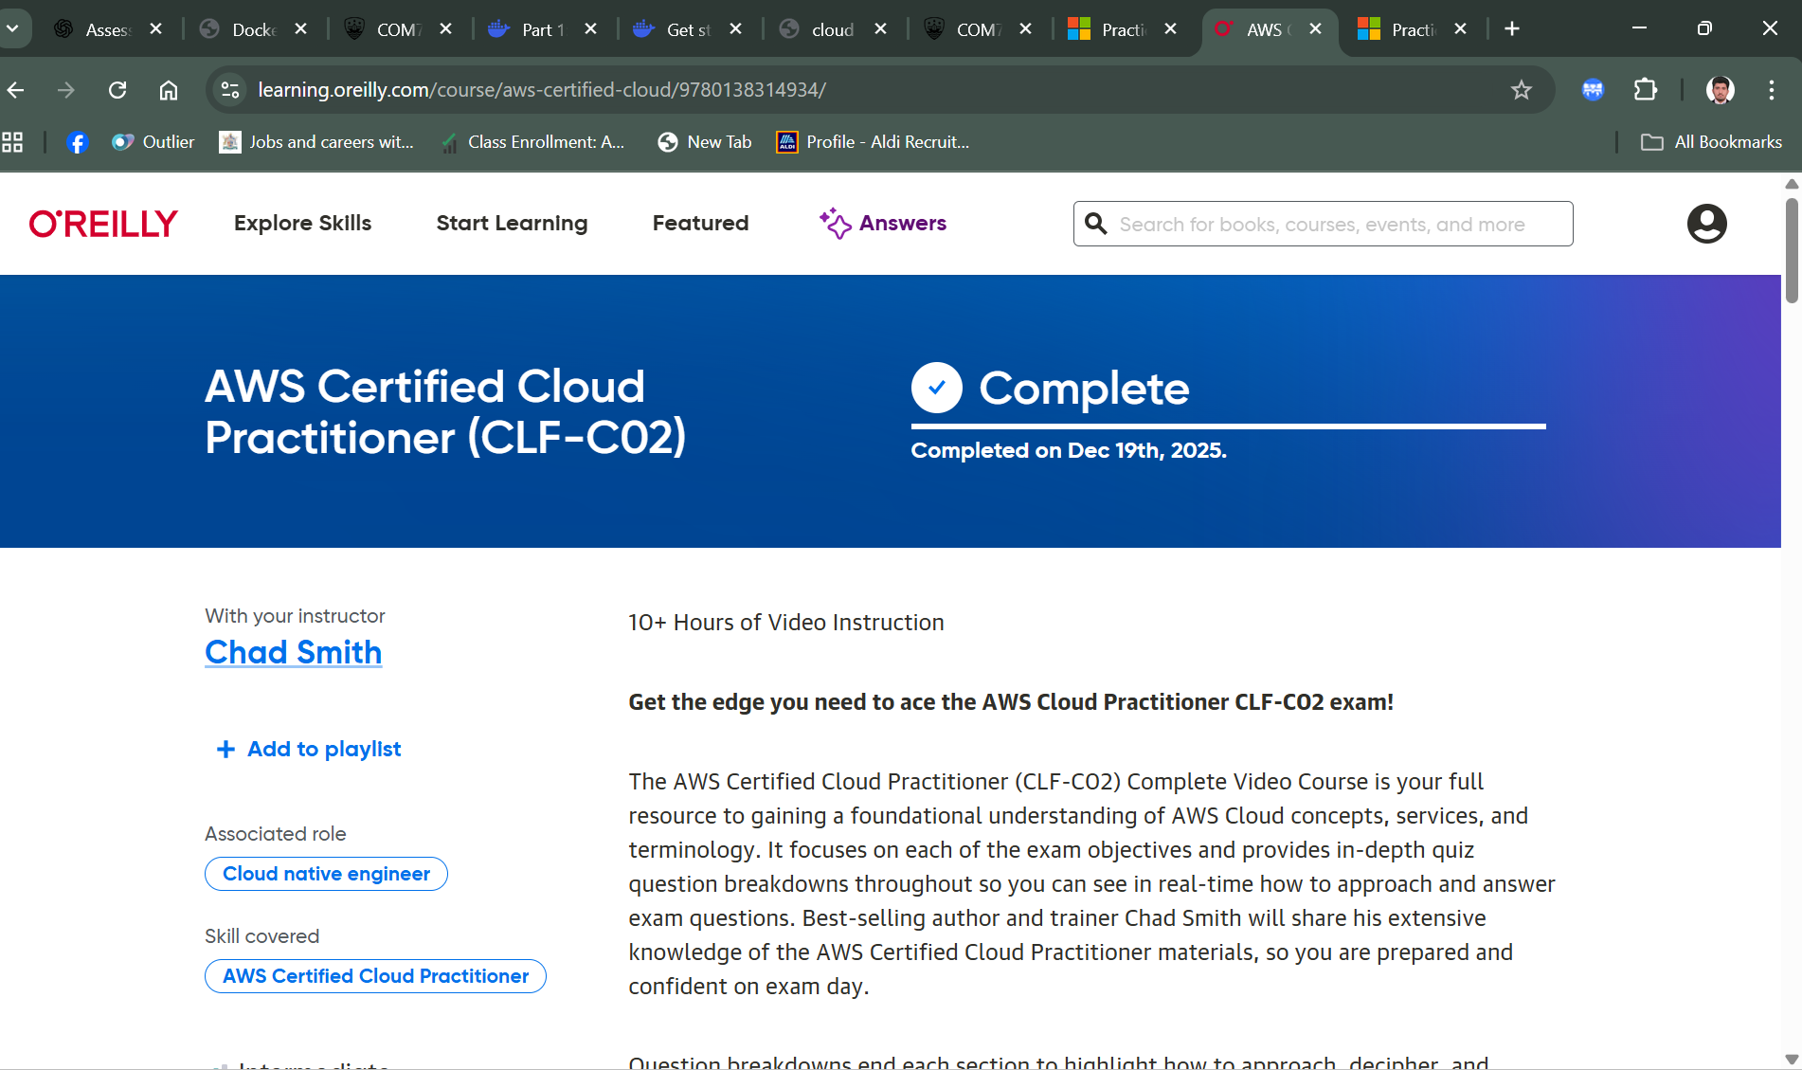
Completed
Enterprise Cloud Computing COM7333 (AI-900)

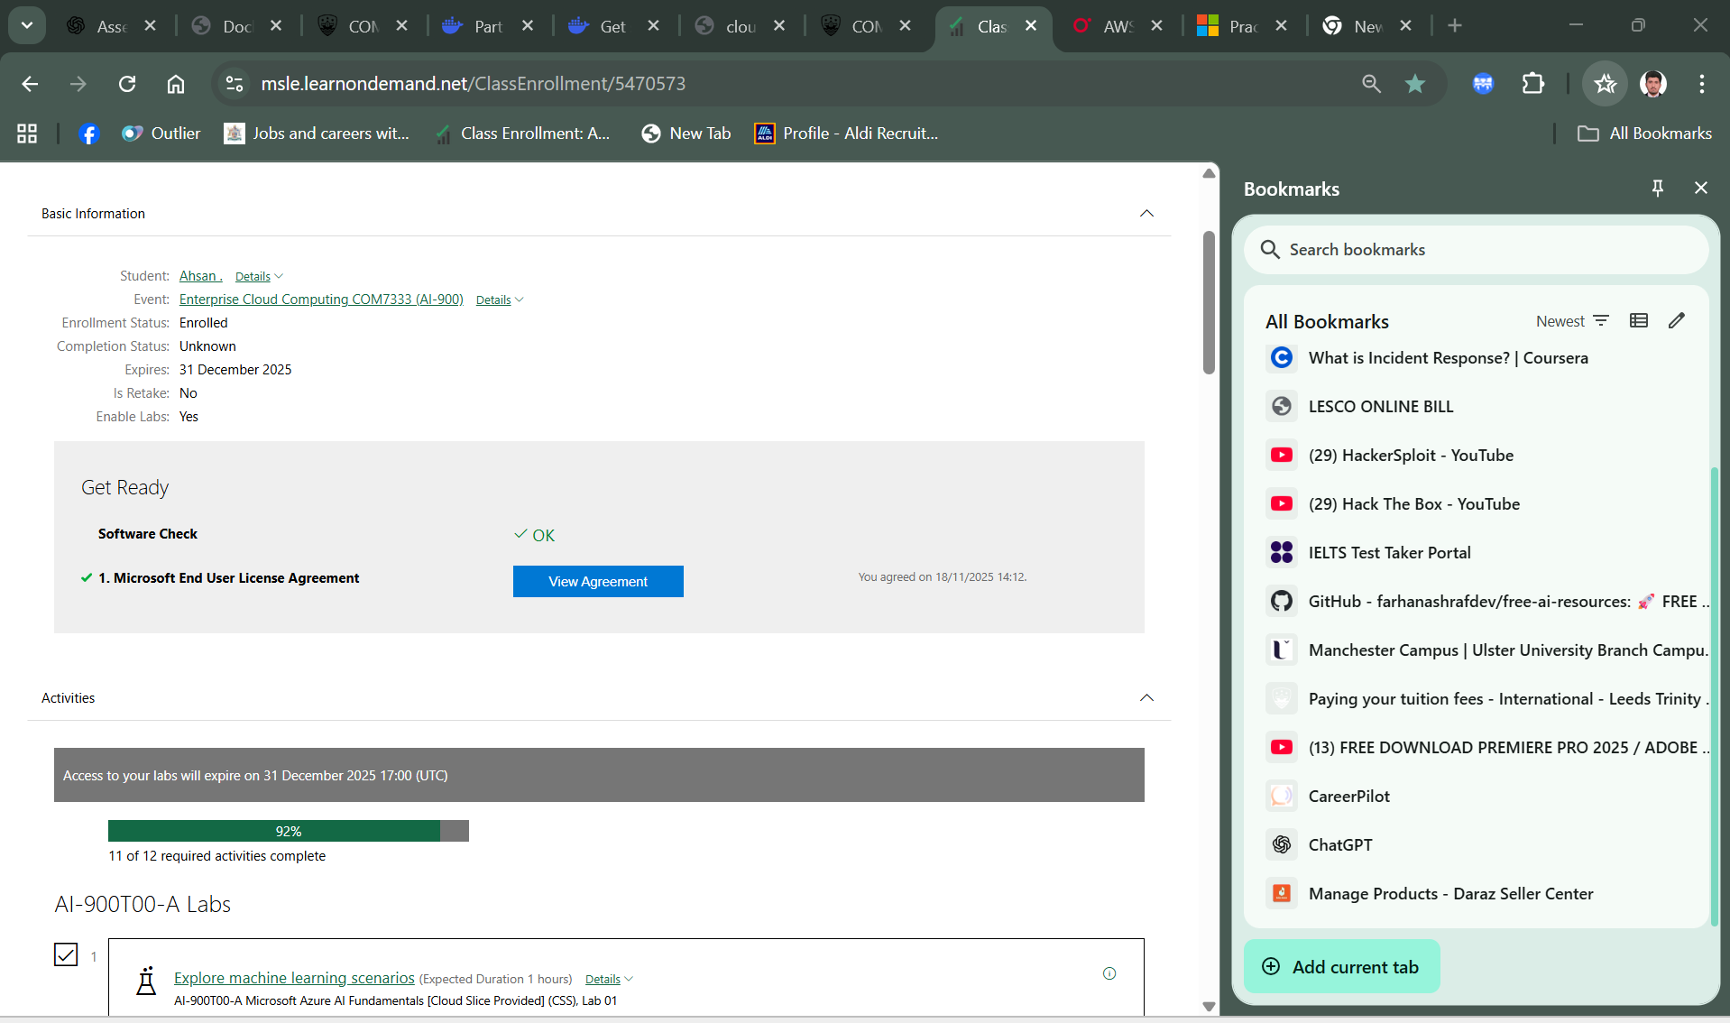

Completed
Enterprise Cloud Computing COM7333 (AZ-900)
